the latest snapshot, as shown in the following screenshot:

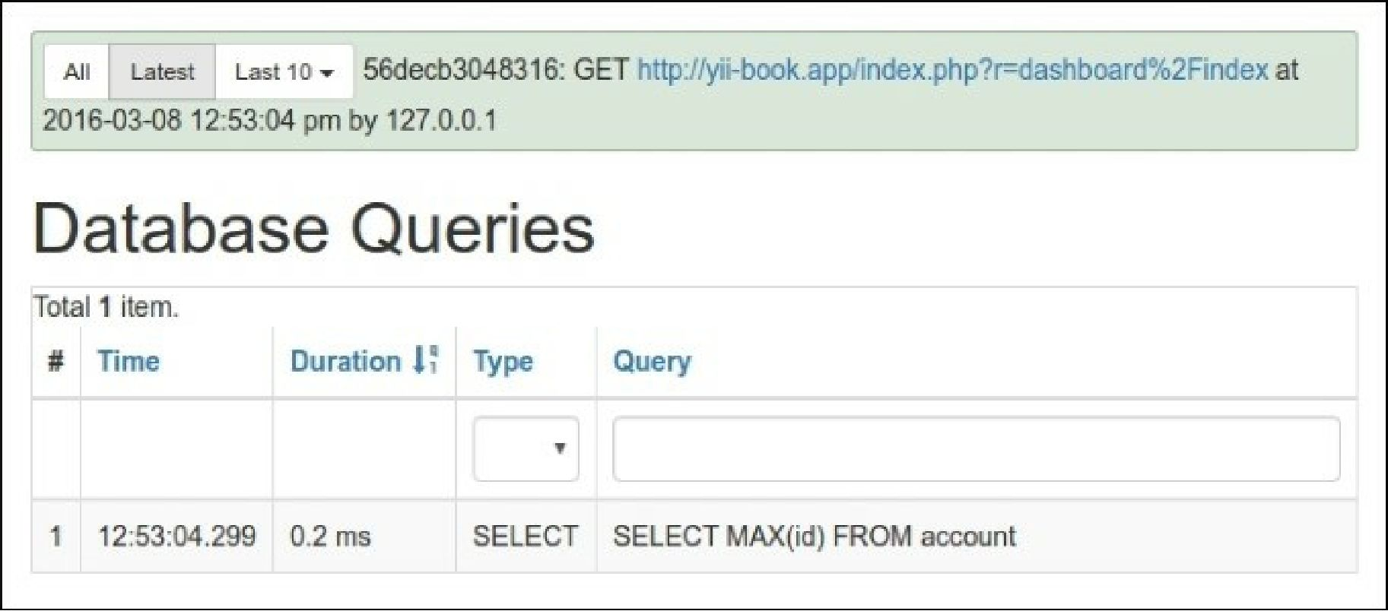

Also, try to run either dashboard/random-operation or dashboard/random-article and refresh dashboard/index after that. The data should change as follows: